Palm Sunday
The Sunday of the Passion

Grace Episcopal Church

The R. Rev. Dr. John C. Bauerschmidt, Bishop
The Rev. Joseph N. Davis, Vicar
Deanie Moore, Director of Music

March 24, 2024
10:00 a.m.

Please turn off all cell phones and keep silence
for ten minutes before the start of the service.

The Liturgy of the Palms
(All who are able gather outside at 9:50 a.m., weather permitting,
for the Palm Liturgy.)

Celebrant: Blessed is the King who comes in the name of the Lord. People: Peace in heaven and glory in the highest.
Celebrant: Let us pray.

Assist us mercifully with your help, O Lord God of our salvation, that we may enter with joy upon the contemplation of those mighty acts, whereby you have given us life and immortality; through Jesus Christ our Lord, Amen.

The Palm Gospel Mark 11:1-11

Priest: The Holy Gospel of our Lord Jesus Christ,
According to Mark.
People: Glory to you, Lord Christ.

Priest: The Gospel of the Lord.
People: Praise to you, Lord Christ.

Blessing of the Palms BCP, p. 271

Priest: The Lord be with you.
People: And also with you.
Priest: Let us give thanks to the Lord our God.
People: It is right to give him thanks and praise.
(The Priest blesses the palms for distribution to the people.)

Celebrant: Blessed is he who comes in the name of the Lord.
People: Hosanna in the highest.
(The palms are distributed to the people.)

Celebrant: Let us go forth in peace.
People: In the name of Christ, Amen.
(All process into the church singing the hymn below.)

The Procession “All Glory, Laud, and Honor”

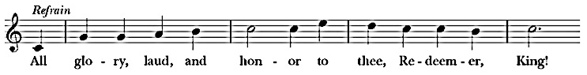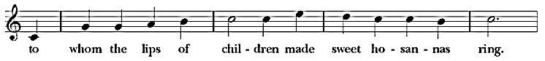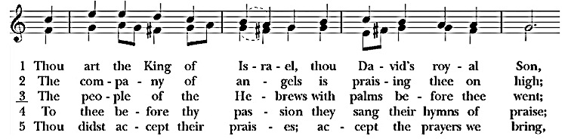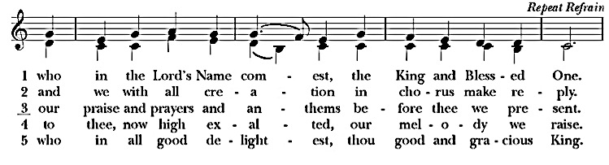

Collect (before the priest enters the chancel) BCP, p 272
Almighty God, whose most dear Son went not up to joy but first he suffered pain, and entered not into glory before he was crucified: Mercifully grant that we, walking in the way of the cross, may find it none other than the way of life and peace; through Jesus Christ our Lord. Amen.

Introit “Ride On! Ride On in Majesty!” Hymn 156

The Word of God

Salutation and Collect of the Day BCP, p. 272

First Reading Isaiah 50:4-9a

The Psalm Psalm 31:9-16

Epistle Philippians 2:5-11

Sequence Hymn “Ah, Holy Jesus” Hymn 158

The Passion
Narrator:
The Passion of our Lord Jesus Christ according to Mark.
(Please see your Passion Narrative. The people read the part of the Assembly. Please stand as you are able.)

The Sermon The Rev. Joseph N. Davis

The Prayers of the People, Form III BCP, p. 392

The Peace BCP, p. 360

Offertory Sentence

Offertory “When I Survey the Wondrous Cross” Hymn 474

The Great Thanksgiving
(All baptized persons are invited to receive communion. If you would like a blessing instead of communion, please cross your arms at the altar rail as the priest approaches. If you need to receive at your seat, please tell an usher.)

Eucharistic Prayer A BCP, p. 361
Sanctus S-124, BCP, p. 362
Lord’s Prayer BCP, p. 364
The Breaking of the Bread
Agnus Dei S-161, BCP p. 407
Post Communion Prayer BCP, p. 366
Prayer Over the People Book of Occasional Services

The Dismissal
Celebrant: Let us go forth in the name of Christ.
People: Thanks be to God.

(All leave in silence.)

Holy Week and Easter Announcements

Please join us for the following services. Times for the services through Holy Week and Easter are as follows. Please note that there will be no Wednesday noon service this Wednesday, March 27.

(3/28) Maundy Thursday 6:00 p.m. Holy Eucharist, Stripping of the Altar
(3/29) Good Friday 3:00 p.m. Sermon, Solemn Collects, and Veneration
of the Cross; Hot Cross Buns in the parish hall
after the service

(3/31) Easter Day 10:00 a.m. Feast of the Resurrection of Our Lord

Each of the services for Holy Week is a unique part of a whole, a liturgical way of walking with Christ through his suffering and death so we can be fully prepared to celebrate his resurrection in Easter Season.

Holy Saturday Service on Saturday, March 30 at 10:00 a.m.

Please join the Daughters of the King at 10:00 a.m. on Holy Saturday, March 30, for the Holy Saturday service from the Book of Common Prayer (BCP p. 283) and join us as we decorate the cross, which we will have venerated on Good Friday.
Carolyn Warnick, President, Daughters of the King

A Note to Visitors

If you are a visitor, we thank you joining us this Sunday. We would like to answer any questions you have about our service or about membership in Grace Church. You may reach out to us at the email addresses listed below.

Giving to Grace Church
You may make a contribution to Grace Church by mail, or you may do so online by scanning the code below with your smartphone. There is also a link to online giving at our website.

Giving for Easter Flowers

If you would like to make an offering for Easter flowers, please make your check out to Grace Church and write “Easter Flowers” on the memorandum line. You may mail in your check, turn it in at the office, or put it in the offering plate at church. You may also give online by selecting Easter Flowers on the menu at the Grace Church website’s giving link. Please include any information about persons in memory of whom you are making your contributions.

Linda Colmore and Father Joe
Grace Episcopal Church

The R. Rev. Dr. John C. Bauerschmidt, Bishop
The Rev. Joseph N. Davis, Vicar
Deanie Moore, Director of Music

5291 N. Main Street
Spring Hill, TN 37174
931-486-3223

Email us:
office@grace4sh.org
fr.joe@gracersh.org

Learn more about Grace Church
on our website at graceepiscopalspringhill.org.

It is the Mission of Grace Episcopal Church to bring glory to God, build the spirituality of our people, and bring Christ to our community.

